COSC 4377 – Networking - Kevin B Long

# interlocking-uh-m-186.eps

Homework #2

Summer 2023

Your name:

Your Student ID:

This homework is based largely on the simulations and animations provided with the book’s companion website. From [this page](https://media.pearsoncmg.com/ph/esm/ecs_kurose_compnetwork_8/cw/), you will find a link to [Interactive Exercises](https://gaia.cs.umass.edu/kurose_ross/interactive/) and [Interactive Animations](https://media.pearsoncmg.com/ph/esm/ecs_kurose_compnetwork_8/cw/#interactiveanimations).

1. Find the Transmission vs Propagation Delay animation [here](https://media.pearsoncmg.com/ph/esm/ecs_kurose_compnetwork_8/cw/content/interactiveanimations/transmission-vs-propogation-delay/transmission-propagation-delay-ch1/index.html). Once you are comfortable with how the tool works, answer the following questions. To get started, you’re going to need some inputs based on your student ID. The remainder when dividing one number by other is calculated with the modulo function. So 10 mod 3 is 1, 10 mod 5 is 0.

For this problem, packet size (in bytes) is ID mod 50, plus 1. What is that?       bytes.

Network length is ID mod 20, plus 1, then times 10. What is that?       km

Transmission rate (a.k.a. bandwidth) is ID mod 500, plus 1. What is that?       kbps

Note that networking calculations use the SI prefixes of kilo versus kibi, so a kilobit is 1,000 (10^3) bits, and a megabit is 1,000,000 (10^6) bits.

Propagation speed is fixed at 2.0E8 m/s.

* 1. One of the configurations the animation offers is a network of 1000km, transmitting at a rate of 512kbps, and with a packet size of 500 bytes. It takes about 8ms before the packet finishes transmitting. How long exactly does it take? Answer with 4 digits of significance (e.g. 8.123).       ms
  2. For that same configuration, how long would the cable need to be to perfectly accommodate the packet so that the first bit had reached the destination just as the last bit finished transmitting?       meters
  3. How long does it take to transmit your packet?      ms   
     *(This will usually be a very small number, a fraction of a millisecond. Nonetheless, answer in ms)*
  4. How long does a bit take to propagate across the cable?       ms
  5. If the cable were exactly long enough to match propagation speed and transmission delay, how long would the cable be?      meters
  6. What is the duration of a single bit?       s (you’ll need to use scientific notation for this one, e.g. 1.938x1E-12)

1. This question is based on the [HTTP Delay Estimation](https://media.pearsoncmg.com/ph/esm/ecs_kurose_compnetwork_8/cw/content/interactiveanimations/http-delay-estimation/index.html) itneractive exercise.
   1. If you have an HTML page to download and on it are 10 other objects, which you choose to download using a keep-alive message in your HTTP GET request so that the connection is persistent, how many round-trip times will be required presuming you do not use any parallelism or pipelining?       RTTs
   2. Suppose an RTT requires 1 second, and the server’s OS closes the TCP connection four seconds after each TCP connection handshake. How many RTTs will be required to complete the download of the page and its objects now?       RTTs
2. This question is based on the [Car Caravan Analogy](https://gaia.cs.umass.edu/kurose_ross/interactive/caravan.php) exercise.
   1. If there were 10 cars traveling at 1 km/min, and the one and only toll booth took 1 minute exactly to process each vehicle, how long would the caravan stretch out on the road past the booth?       km

For the rest of this problem, calculate the constants:

The number of cars is your ID mod 10, plus 5. What is that?       cars

The number of toll booths is ID mod 3, plus 2. What is that?       booths

The time to service a vehicle at a booth is ID mod 10, plus 2. What is that?       sec

The distance between toll booths is ((ID mod 10) + 1)*10. What is that?       km

The speed of the vehicles is ((ID mod 5) + 1)*10. What is that?       km/hour.

* 1. How long does it take for the entire caravan to receive service at the tollbooth (that is the time from when the first car enters service until the last car leaves the tollbooth)?       sec
  2. Once the first car leaves the tollbooth, how long does it take until it arrives at the next tollbooth?       sec
  3. Are there ever two cars in service at the same time, one at the first toll booth and one at the second toll booth? Answer Yes or No
  4. Are there ever zero cars in service at the same time, i.e., the caravan of cars has finished at the first toll both but not yet arrived at the second tollbooth? Answer Yes or No
  5. Use the same numbers as in your homework #2 problem #3 for the constants to answer these questions:
     1. How long does the road need to be so that the caravan fills the road with the first car arriving at the second toll booth and the last car leaving the first?       km

1. This problem is based on the [Queueing Delay](https://gaia.cs.umass.edu/kurose_ross/interactive/qdelay.php) interactive exercise. Use these constants:

Your transmission rate R bps is your ((ID mod 20) + 11) * 50,000. What is that?       bps

Your packet length is ((ID mod 65) + 11) * 100. What is that?       bits

a1 = (ID mod 20) + 21. What is that?       packets/second

a2 = (ID mod 60) + 201. What is that?       p/s

1. What is the value of I, the traffic intensity, for an arrival rate of a1?
2. What is the value of I for an arrival rate of a2?
3. What is the queueing delay if the average rate of packets/sec is a1?       ms
4. What is the queueing delay if the average rate of packets/sec is a2?       ms
5. Assuming an infinite router buffer, a current queueing delay part from part d, and 5000 packets arrive, how many packets will be in the buffer 1 second later?   
         packets
6. This problem is based on the [Computing End-End Delay](https://gaia.cs.umass.edu/kurose_ross/interactive/end-end-delay.php) automation.

Refer to the diagram from the web page. Here is an EXAMPLE. Your #s will be different!

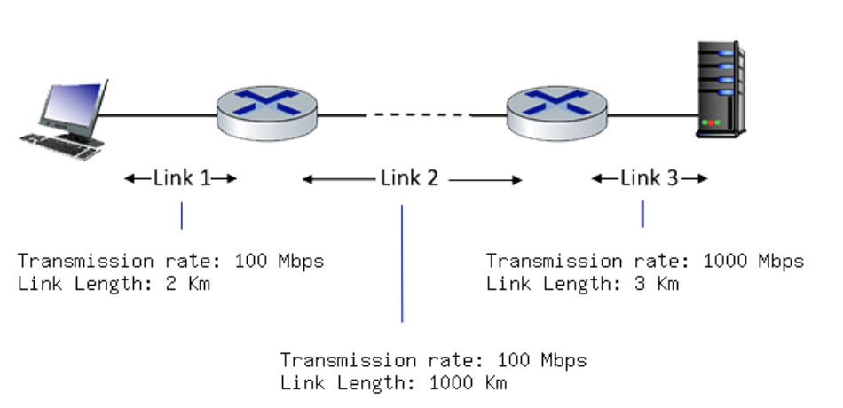

Use these constants:

Packet size in bits: ((ID mod 65) + 11) * 100 bits

Propagation speed: 3.0*10^8 m/s

Rate of link one: ((ID mod 5)+1)*100 =       Mbps

Length of link one: (ID mod 5)+2 =       km

Rate of link two: ((ID mod 10)+1)*100 =       Mbps

Length of link two: ((ID mod 10)+1)*500 =       km

Rate of length three: ((ID mod 10)+1)*100 =       Mbps

Length of length three: (ID mod 3)+4 =       km

1. What is the transmission delay of link 1:       ms (you can write this in scientific notation if you like –3.023*E-2 for example, as long as it’s in milliseconds)
2. What is the transmission delay of link 2:       ms
3. What is the transmission delay of link 3:       ms
4. What is the propogation delay of link 1:       ms
5. What is the propogation delay of link 1:       ms
6. What is the propogation delay of link 2:       ms
7. What is the propogation delay of link 3:       ms
8. What’s the total delay of link 1 (trans + prop):       ms
9. What’s the total delay of link 2 (trans + prop):       ms
10. What’s the total delay of link 3 (trans + prop):       ms
11. What’s the total delay of the network (trans + prop):       ms
12. This problem is based on the simulator for [RTT and Timeout](https://gaia.cs.umass.edu/kurose_ross/interactive/TCP_RTT.php) values.

If you have a starting EstimatedRTT of 200ms and a DevRTT or 50ms, and then a packet arrives whose delay is calculated by: ((ID mod 10)-4)*6 + 3, then what are the new values for:

* 1. Estimated RTT =       ms
  2. DevRTT =       ms
  3. TCP Timeout =       ms

1. TCP windowing.

This problem is based on the one we did in the last couple of lectures. A finished product will have an ssthresh line and a cwnd (window size) line.

Here is a finished example like we did in class:

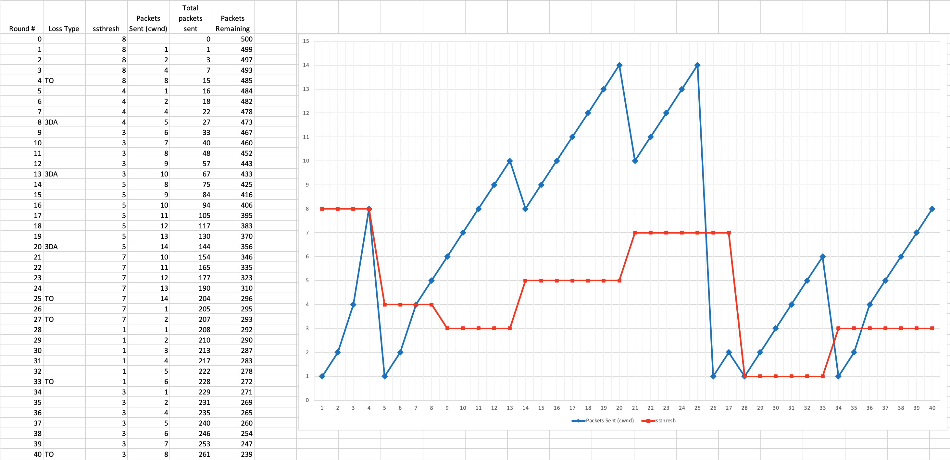

Your task is to draw the ssthresh and cwnd lines (red and blue) based on the following types of losses in the specified transmission rounds:

Round 4: if your ID is even, then TO, otherwise 3DA. Which will you do?

Round 5: if your ID mod 10 = 0 through 4, then TO, o/wise 3DA. Which is it?

Round 9: if your ID mod 50 = 0-24, then 3DA, o/wise TO. Which is it?

Round 26: if your ID mod 100 <50, then 3DA, o/wise TO. Which is it?

Round 37: if your ID mod 10 < 5, then 3DA o/wise TO. Which is it?

Draw your graph as we described in Lecture 12.

